*Time zone For Central European Time

|  |  |
| --- | --- |
| TUESDAY 16 March | WEDNESDAY 17 March |
| |  | | --- | | **10:00\*** Opening Speeches   * Dr. Özgür Tarhan, UIO Coordinator * Prof. Dr. Ekrem Savaş, Rector * General Presentation of Usak University and Virtual Tour on the Campus   11:00 *Break*  11:30 Keynote Speeches   * To be announced soon * To be announced soon   12:30 *Break*  14:00 Introduction to basic Turkish culture, history of Uşak   * Uşak’s tarhana, whirling dervish, traditional carpets * Live Ebru training. | | |  | | --- | | 09:30 **Virtual and** Blended Mobility in the New Erasmus + Programme   * Speaker- To be announced soon   **10:00** Presentation of   * Erasmus+ Projects at UU * SEVEN Consortium ppt * Er+ ICM, 107 ppt * Mevlana Exc.Prog. ppt*”* | | **12:30**  *Break* |  |  | | --- | | **13:30**   * Challenge for the participants to introduce their universities in 5 min. | | * Parallel Sessions | | 14:30 Round Table Workshops (multiple rooms) | |

USAK UNIVERSITY

**International Staff Week**

**16th – 17th March 2021**

**“DIGITAL NETWORK-IN”**

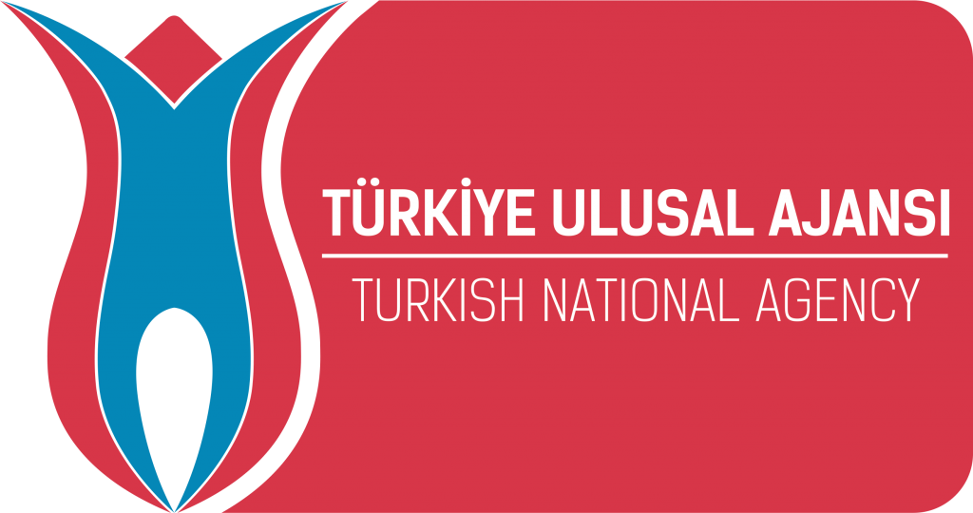

e-mail: [erasmus@usak.edu.tr](mailto:erasmus@usak.edu.tr)  
phone: + 90 276 221 21 21 (ext: 4100, 4101)

