****

**USEFUL INFORMATION FOR INCOMING ERASMUS+ STAFF MOBILITY**

**ACCOMMODATION**

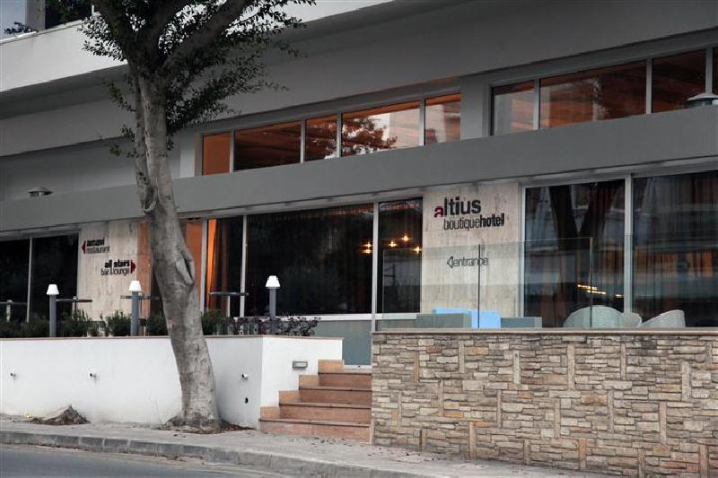**Altius Boutique Hotel \*\*\***

The new and elegant Altius Boutique Hotel is ideally located in a quiet residential area, yet within walking distance from the Nicosia city centre. Offering a family friendly atmosphere the Altius provides personalised care and modern facilities.

Distance from UNic: 3,4 km

\*Only for UNic guests

Web page: <http://altiushotel.com/HOME>

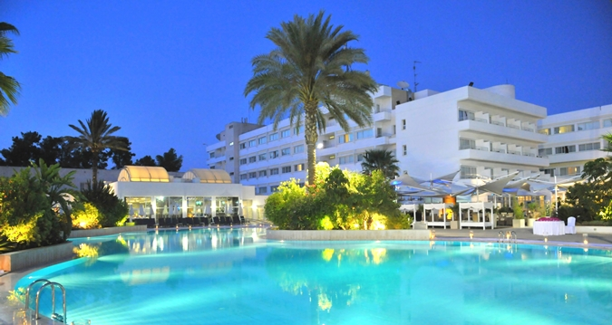**Hilton Park \*\*\*\***

Hilton Park Nicosia provides the kind of service, comfort and amenities the Hilton brand guarantees worldwide. Whether you prefer formal or casual dining, a lively atmosphere or something more intimate, you can find it in Hilton Park Nicosia. In addition to local and international cuisine, you can enjoy traditional afternoon tea, live jazz and Greek music or lounge on a divan next to the boat-shaped bar.

Distance from Unic: 1,7 km

Rates: approximately 130 € / night

Web page: <http://www3.hilton.com/en/hotels/cyprus/hilton-park-nicosia-NICLEHI/index.html>



**Centrum Hotel\*\*\***

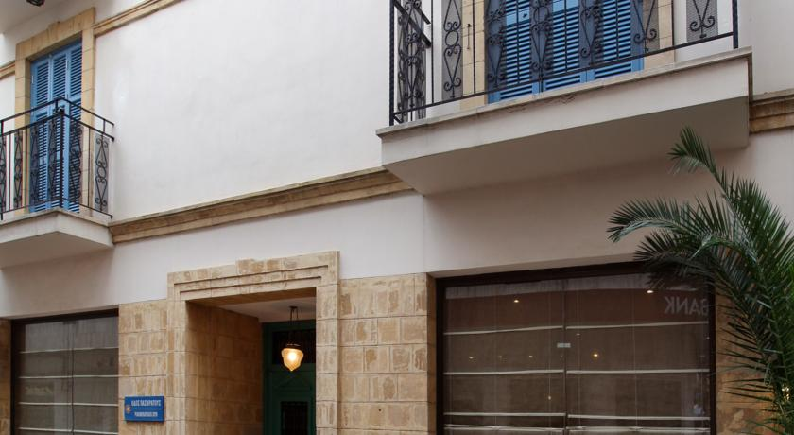In the center of Nicosia within the walled city, the Centrum Hotel features elegant and spacious accommodations with free Wi-Fi and a buffet breakfast served on an open-air terrace. It is just steps from the upgraded areas of Ledra and Onasagorou Street, where guests can explore restaurants, cafes, and museums

Distance from UNic: 6,1 km

Rates: approximately 70 € / night

Web page: <http://www.centrumhotelcyprus.com/>

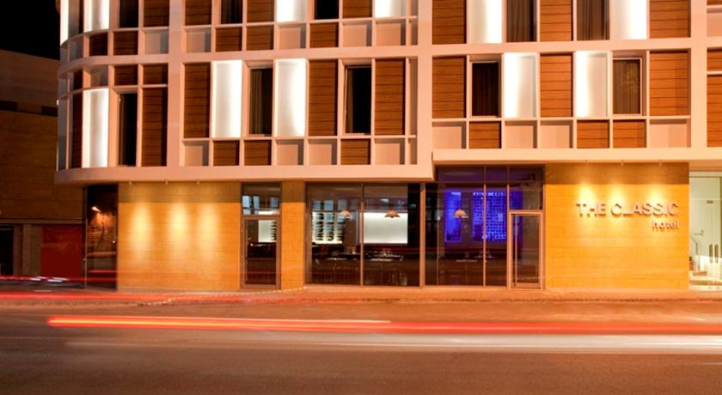**The Classic Hotel\*\*\***

The Classic Hotel is located in the old city quarters of Nicosia, right in the heart of the business. The recently redesigned hotel blends perfectly with its environment, offering [comfortable accommodation](http://www.classic.com.cy/standard-classic-room), [conference rooms](http://www.classic.com.cy/conferences-banqueting-overview) and a multitude of facilities just a few minutes walk from the city’s business and [commercial centre](http://www.classic.com.cy/things-to-experience-categories), as well as many [government offices](http://www.classic.com.cy/business-in-the-area-categories).

Distance from UNic: 4,8 km

Rates: approximately 70 € / night

Web page: <http://www.classic.com.cy/home>

**Asty Hotel\*\***

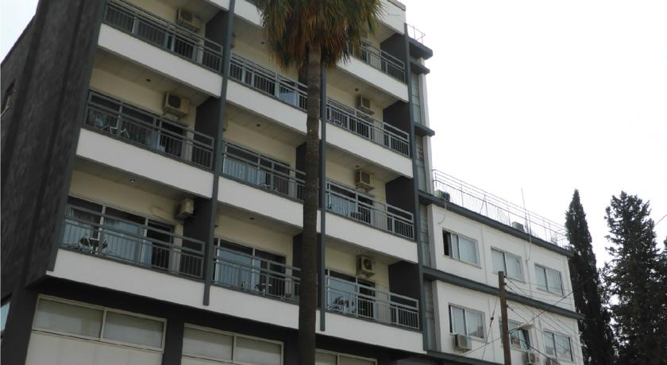The Asty Hotel is situated in a picturesque neighborhood and the embassy area of Nicosia. It is a family-run hotel, with helpful owners and friendly staff that go out of their way to make guests feel at home, offering them many complimentary facilities, including internet throughout, a shuttle service, and 24/7 nibbles and drinks. At this hotel you experience true Cypriot hospitality, and are treated as a guest and not a room number.

Distance from UNic: 2,6 km

Rates: approximately 45 € / night

Web page: <http://astyhotel.com/astypages/index.html>

**** P

**Europa Plaza Hotel\*\*\***

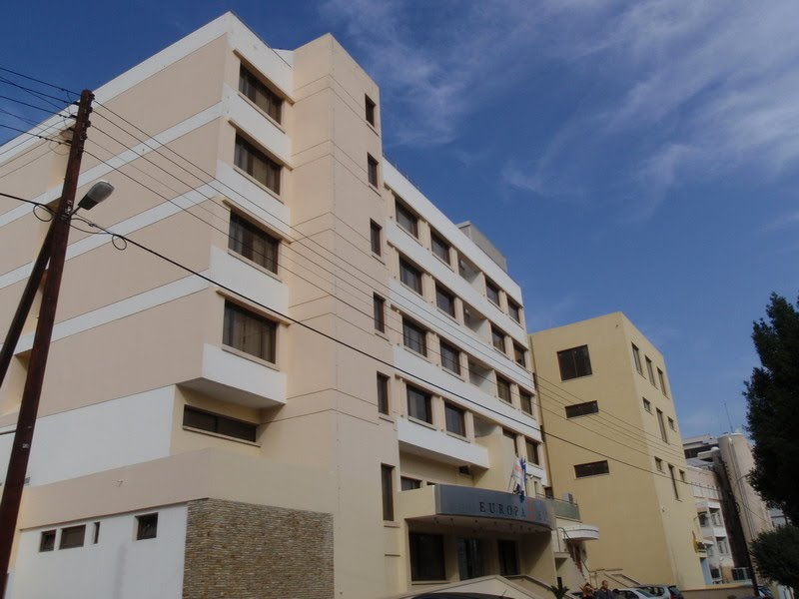Europa Plaza Hotel is located in the heart of the Business District of Nicosia. A small boutique hotel with forty rooms, six executive rooms and four executive suites, perfectly located in a quiet area of the Business District of Nicosia, right in the center of everything, Government offices, Ministries, Embassies and Banking institutions Also within five minute walk from Nicosia Archaeological Museum, Migration office, Hospitals, House of Parliament and many more sites of interest in Nicosia.Hotel offers FREE Wi-Fi in public areas, verandas and all the rooms. Also offers free of charge assistance and printing services to Hotel’s guest.

13, Alkaios Street, Engomi, CY-2404 Nicosia

P.O.Box 25730, CY-1311

**Tel:** 22 692692, Fax: 22 664417

**E-mail:** [reception@europaplazahotel.com](mailto:reception@europaplazahotel.com)

Distance from UNic: 3.5 Km

\*Only for UNic Guests

**Website:** [http://www.europaplazahotel.com](http://www.europahotel.com.cy)



**TRANSPORTATION FROM LARNACA AIRPORT TO NICOSIA**

1. Arrange a pick up taxi service (approximately 40-50 euro). We can arrange this for you, so please contact the Erasmus Office, if interested.
2. Take a taxi from the airport (available 24 hours)
3. Kapnos shuttle: <http://www.kapnosairportshuttle.com/> (8 euro)
4. Travel express: <http://www.travelexpress.com.cy/> (11 euro)

**TRANSPORTATION FROM THE CITY CENTRE TO UNIC**

* OSEL website: [http://www.osel.com.cy/?wp=index\_en](http://www.osel.com.cy/?wp=index_en" \t "_blank)

This is the website that provides information on public transportation in Nicosia

* From Solomou square (Diagorou street) take Bus 259 to University of Nicosia.

259 bus route details: <http://www.osel.com.cy/?wp=routedetails_en&route=259>

**CONTACT DETAILS**

|  |  |
| --- | --- |
| **UNIVERSITY OF NICOSIA**  46 Makedonitissas Avenue  1700 Nicosia, Cyprus | C:\Users\Evi Eftihiou\Pictures\unic-aerial_1.jpg |

**ERASMUS OFFICE:**

University of Nicosia, Millennium Building, 1st Floor

* **Dr. Evi Eftychiou, Erasmus Institutional Coordinator / Erasmus Office Head**

Email: [Eftychiou.e@unic.ac.cy](mailto:Eftychiou.e@unic.ac.cy), Tel. [+35722841727](tel:%2B35722841727), Office number: M114

* **Ms. Georgia Argyrou, Erasmus Officer**

Email: [Argyrou.g@unic.ac.cy](mailto:Argyrou.g@unic.ac.cy), Tel. [+35722841571](tel:%2B35722841571), Office number: M102C

* **Ms. Stella Stylianou, Erasmus Assistant Officer**

Email: [stylianou.st@unic.ac.cy](mailto:stylianou.st@unic.ac.cy) , Tel. [+35722841726](tel:%2B35722841726), Office number: M102B